I am giving brief steps for MATLAB installation

<https://allpcworld.com/mathworks-matlab-2014-for-windows-free-download>

* download the complete set of files and folders
* Doubke click on setup file
* Use this option when asked

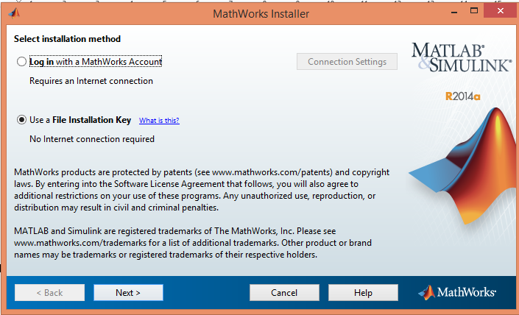

* Click next
* Select ok-> click on next

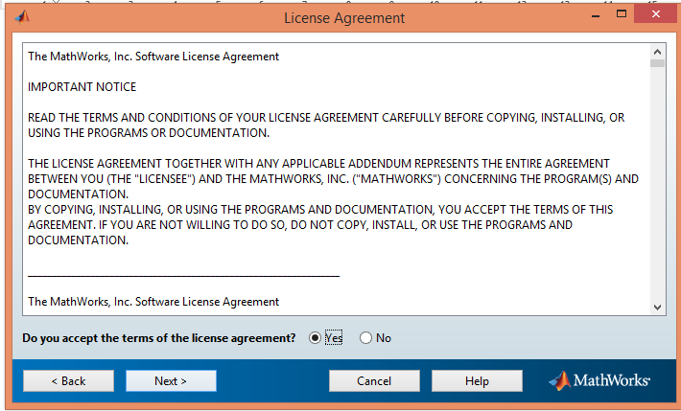

* Copy licence key from readme file and paste -> click on next
* 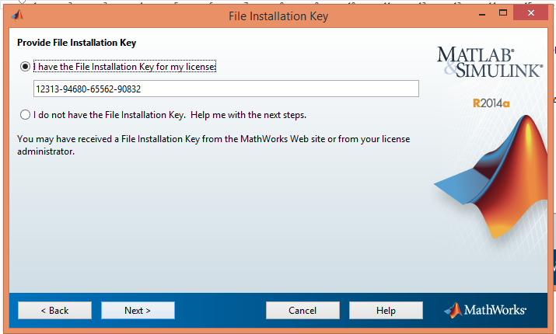
* Choose folder where you want to store matlab documents-> click on next
* 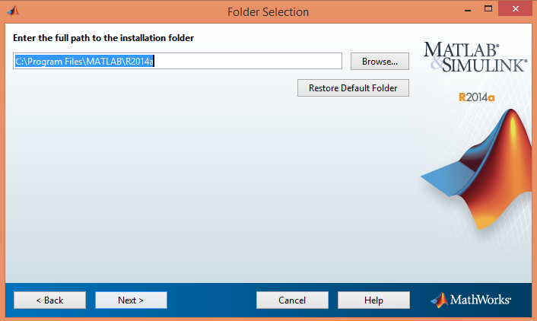
* Select all toolboxex by checking boxes-> click on next
* 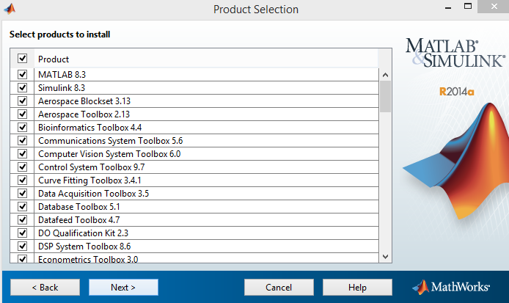
* After few more steps when it ask for licence brose the path for licence( licence will be thr in downloaded files only))
* It will install and show window saying installation completed.
* Once installation is complete copy **Win64** folder from **bin folder of downloaded** files to **bin folder of local folder** you chose in previous step

**Restart your computer and open MATLAB**